**Nasdaq Dividend calendar**

1. URL;

<https://api.nasdaq.com/api/calendar/dividends?date=2022-06-01>

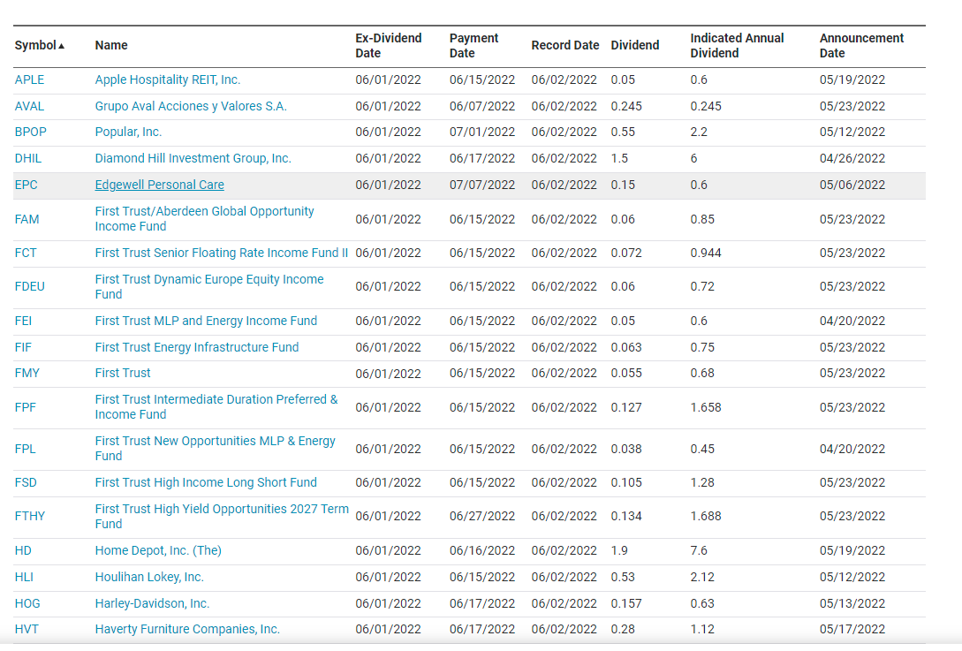

1. Each time run from Today till Today + 7 Days

<https://api.nasdaq.com/api/calendar/dividends?date=2022-06-01>

[https://api.nasdaq.com/api/calendar/dividends?date=2022-06-0](https://api.nasdaq.com/api/calendar/dividends?date=2022-06-01)2

[https://api.nasdaq.com/api/calendar/dividends?date=2022-06-0](https://api.nasdaq.com/api/calendar/dividends?date=2022-06-01)3

[https://api.nasdaq.com/api/calendar/dividends?date=2022-06-0](https://api.nasdaq.com/api/calendar/dividends?date=2022-06-01)4

[https://api.nasdaq.com/api/calendar/dividends?date=2022-06-0](https://api.nasdaq.com/api/calendar/dividends?date=2022-06-01)5

[https://api.nasdaq.com/api/calendar/dividends?date=2022-06-0](https://api.nasdaq.com/api/calendar/dividends?date=2022-06-01)6

[https://api.nasdaq.com/api/calendar/dividends?date=2022-06-0](https://api.nasdaq.com/api/calendar/dividends?date=2022-06-01)7

1. Table definition attached.
2. URL response;

{"data":{"calendar":{"headers":{"symbol":"Symbol","companyName":"Name","dividend_Ex_Date":"Ex-Dividend Date","payment_Date":"Payment Date","record_Date":"Record Date","dividend_Rate":"Dividend","indicated_Annual_Dividend":"Indicated Annual Dividend","announcement_Date":"Announcement Date"},"rows":[{"companyName":"Ardagh Metal Packaging S.A.","symbol":"AMBP","dividend_Ex_Date":"06/13/2022","payment_Date":"06/28/2022","record_Date":"06/14/2022","dividend_Rate":0.1,"indicated_Annual_Dividend":0.4,"announcement_Date":"N/A"},{"companyName":"Best Buy Co., Inc.","symbol":"BBY","dividend_Ex_Date":"06/13/2022","payment_Date":"07/05/2022","record_Date":"06/14/2022","dividend_Rate":0.88,"indicated_Annual_Dividend":3.52,"announcement_Date":"05/24/2022"},{"companyName":"Camping World Holdings, Inc.","symbol":"CWH","dividend_Ex_Date":"06/13/2022","payment_Date":"06/29/2022","record_Date":"06/14/2022","dividend_Rate":0.625,"indicated_Annual_Dividend":2.5,"announcement_Date":"05/17/2022"},{"companyName":"Gamco Investors, Inc.","symbol":"GBL","dividend_Ex_Date":"06/13/2022","payment_Date":"06/28/2022","record_Date":"06/14/2022","dividend_Rate":0.04,"indicated_Annual_Dividend":0.16,"announcement_Date":"05/03/2022"},{"companyName":"Heritage Insurance Holdings, Inc.","symbol":"HRTG","dividend_Ex_Date":"06/13/2022","payment_Date":"07/05/2022","record_Date":"06/14/2022","dividend_Rate":0.06,"indicated_Annual_Dividend":0.24,"announcement_Date":"05/05/2022"},{"companyName":"New Fortress Energy Inc.","symbol":"NFE","dividend_Ex_Date":"06/13/2022","payment_Date":"06/28/2022","record_Date":"06/14/2022","dividend_Rate":0.1,"indicated_Annual_Dividend":0.4,"announcement_Date":"05/04/2022"},{"companyName":"Saratoga Investment Corp","symbol":"SAR","dividend_Ex_Date":"06/13/2022","payment_Date":"06/29/2022","record_Date":"06/14/2022","dividend_Rate":0.53,"indicated_Annual_Dividend":2.12,"announcement_Date":"05/26/2022"},{"companyName":"STERIS plc","symbol":"STE","dividend_Ex_Date":"06/13/2022","payment_Date":"06/28/2022","record_Date":"06/14/2022","dividend_Rate":0.43,"indicated_Annual_Dividend":1.72,"announcement_Date":"05/04/2022"}]},"timeframe":{"minDate":"2011-09-22T00:00:00","maxDate":"2022-12-27T00:00:00"}},"message":null,"status":{"rCode":200,"bCodeMessage":null,"developerMessage":null}}

1. Attached Zipped file for another script, which uses an API from same source, but different area.